**PEMROGRAMAN JARINGAN**

**INTERNET ADDRESS**



**Oleh :**

**Nama : Rhezaldi Irnantyo Irawan**

**Kelas : TI-3E**

**NIM : 1841720164**

**PROGRAM STUDI TEKNIK INFORMATIKA**

**JURUSAN TEKNOLOGI INFORMASI**

**POLITEKNIK NEGERI MALANG**

1. Coba tuliskan dan kerjakan kode di atas dan laporkan hasil keluaran aplikasi tersebut.

=

* Source Code

|  |
| --- |
| Modul2.java |
| /*  * To change this license header, choose License Headers in Project Properties.  * To change this template file, choose Tools | Templates  * and open the template in the editor.  */  package JaringanJs;  import java.net.InetAddress;  import java.net.UnknownHostException;  /**  *  * @author User  */  public class Modul2 {  public static void main(String[] args)  {  try {  InetAddress inet1 =  InetAddress.getByName("www.polinema.ac.id");  System.out.println(  "HostAddress=" + inet1.getHostAddress());  InetAddress inet2 =  InetAddress.getByName("192.168.134.134");  System.out.println("HostName=" + inet2.getHostName());  if (inet1.equals(inet2))  System.out.println("Alamat sama !");  else System.out.println ("Alamat tidak sama!");  }  catch (UnknownHostException e) {  e.printStackTrace();  }  }  } |

* Output

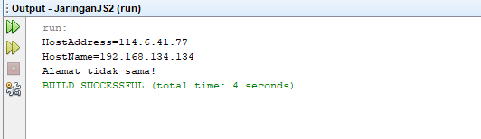

Hasil tidak sama karena Ipnya berbeda

1. Buatlah aplikasi yang menggunakan objek InetAddress di mana anda bisa memasukkan nama host, lalu output yang dikeluarkan adalah alamat IP dari nama host yang diinputkan

=

* Source Code

|  |
| --- |
| Modul2No2.java |
| /*  * To change this license header, choose License Headers in Project Properties.  * To change this template file, choose Tools | Templates  * and open the template in the editor.  */  package JaringanJs;  import java.util.*;  import java.net.*;  /**  *  * @author User  */  public class Modul2No2 {  public static void main(String args[]){  String hostname;  Scanner sc = new Scanner(System.in);  System.out.print("Masukkan Alamat URL Yang Ingin DIcari : ");  hostname = sc.next();  try{  InetAddress address = InetAddress.getByName(hostname);  System.out.println("IP address dari " + address.toString());  }  catch(UnknownHostException e){  System.out.println("IP tidak diketahui,silahkan coba lagi ");  }  }  } |

* Output

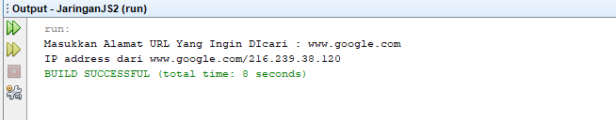

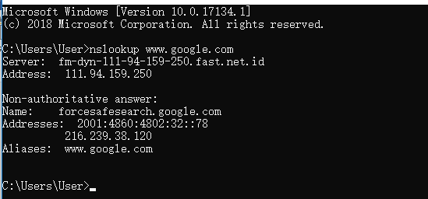

1. Buatlah aplikasi yang menggunakan objek InetAddress di mana anda bisa memasukkan ip address, lalu aplikasi akan mengeluarkan output nama host dari IP yang diinputkan

=

* Source Code

|  |
| --- |
| Modul2no3.java |
| /*  * To change this license header, choose License Headers in Project Properties.  * To change this template file, choose Tools | Templates  * and open the template in the editor.  */  package JaringanJs;  import java.util.*;  import java.net.*;  /**  *  * @author User  */  public class Modul2no3 {  public static void main(String[] args) {  String ip;  Scanner sc = new Scanner(System.in);  System.out.print("Masukkan ip : ");  ip = sc.nextLine();  try {  InetAddress inetAddr = InetAddress.getByName(ip);    String hostname = inetAddr.getHostName();  System.out.println("Hostname : " + hostname);  }  catch (UnknownHostException e) {  System.out.println("Host Address tidak ada : ");  }  }  } |

* Output

